Project Development PhaseSprint II

SPRINT TARGETS:
Sprint | Functional Requirement (Epic) | User Story Number | User Story / Task | Story Points | Priority | Team Members
Sprint-2 | Safe Ride | USN-4 | As a traveler , I should  have a hustie free  journey | 20 | Medium | Pavithra Rohini Naresh Mallisri
Date | 15 November 2022
Team ID | PNT2022TMID44492
Project Name | Signs with Smart Connectivity for better road safety

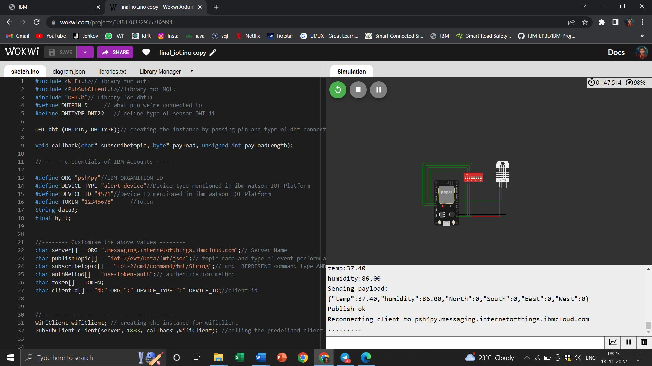
Wokwi Simulation: https://wokwi.com/projects/348178332935782994

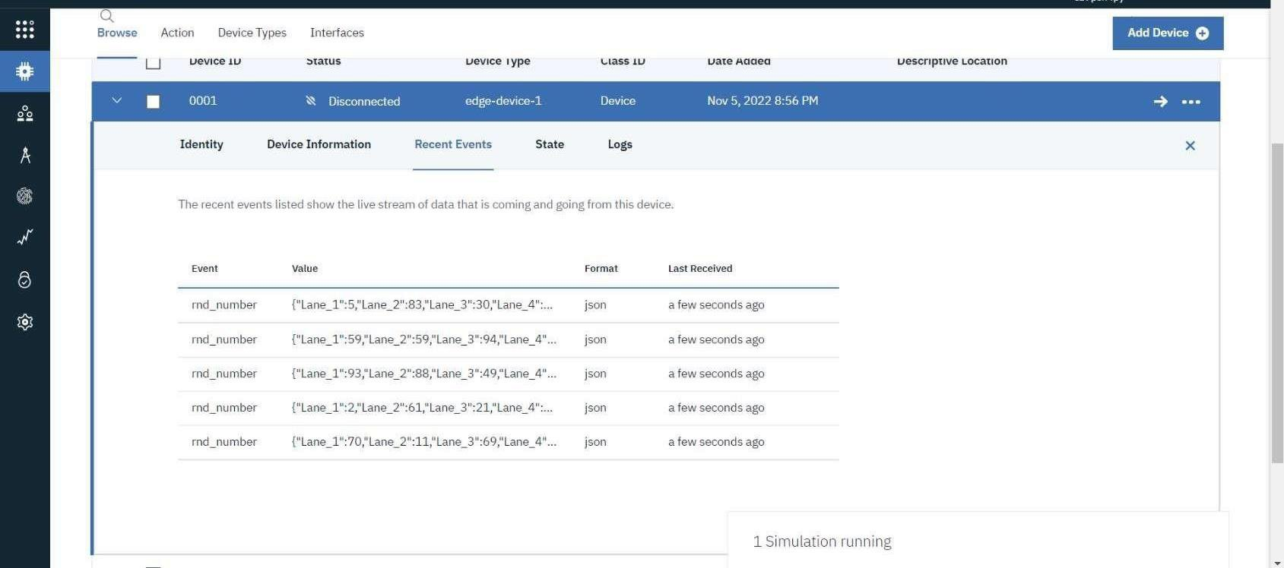
IoT Device – IoT Platform

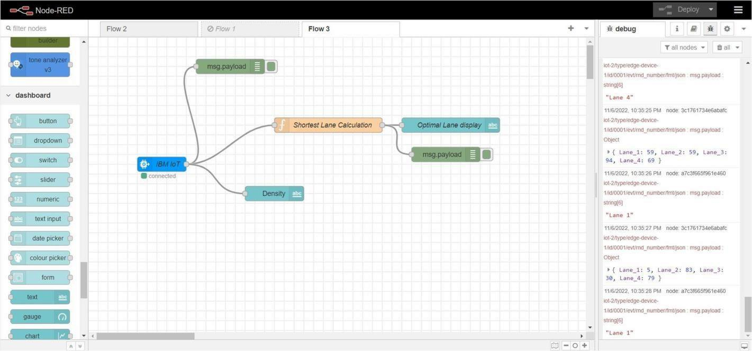
Node Red
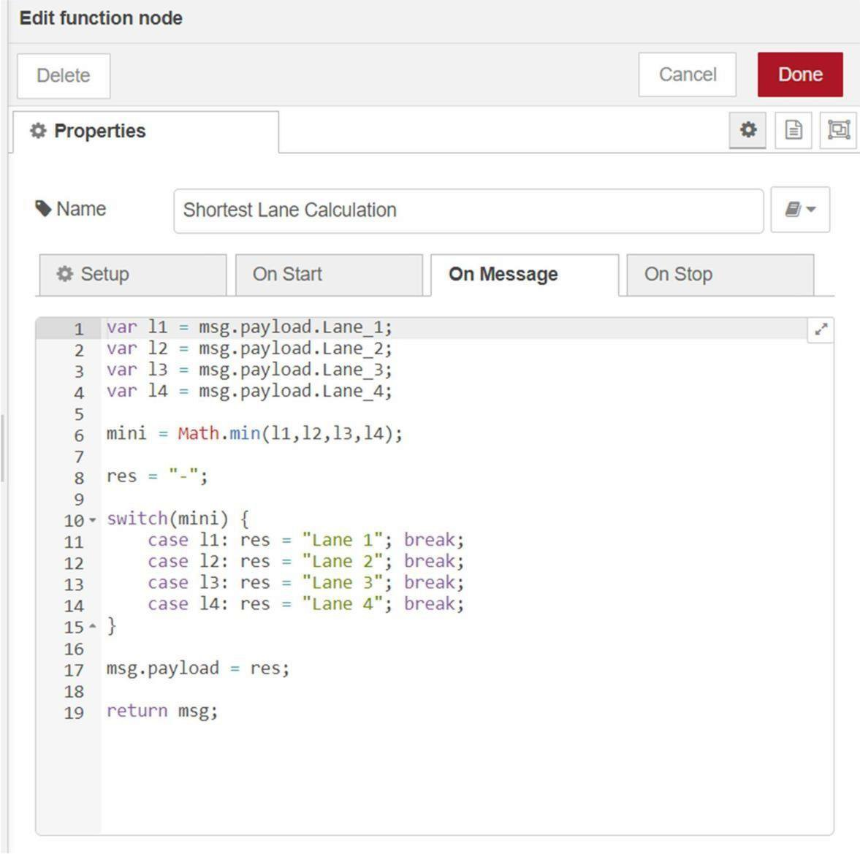
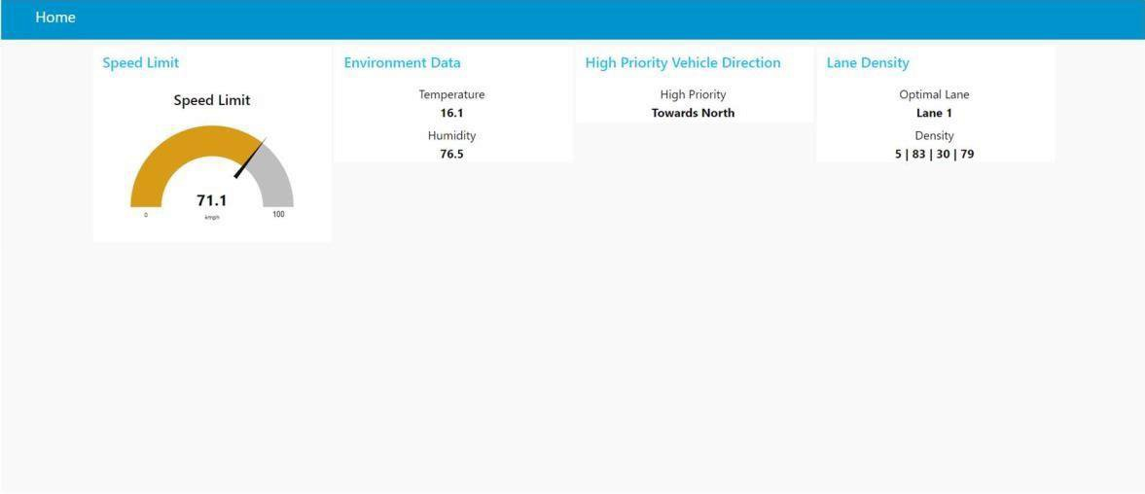
Node Red Web UI

